Step : 1 Create database and tables.

CREATE database JK_Tech_DB

use Jk_Tech_DB

create table Department

(

DepaertmentId int primary key identity(1001,1),

Name varchar(50)

)

alter table Department add Location varchar(100)

select * from Department

insert into Department values('Admin','Delhi')

insert into Department values('HR','Mumbai')

insert into Department values('IT','Bangalore')

create table Employee

(

EmployeeId int primary key identity,

Name varchar(50),

Gender varchar(10),

Designation varchar(50),

Salary int,

Deptid int ,constraint fk_did foreign key(deptid) references Department(DepaertmentId))

insert into Employee values ('Vishwas','Male','Trainee',25000,1001)

select * from Employee

step 2: Create MVc Application

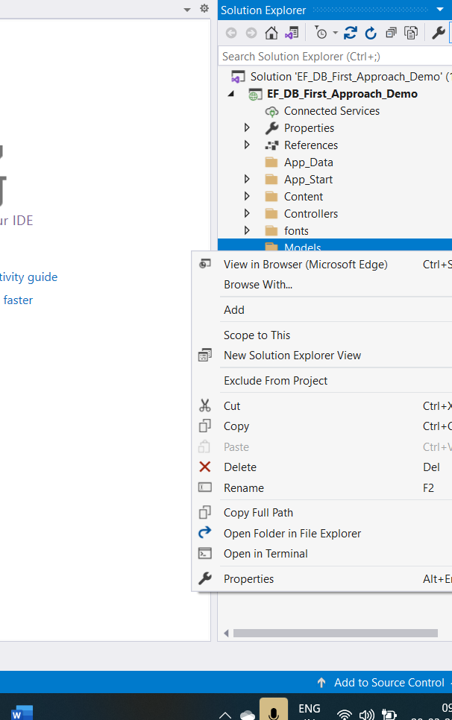

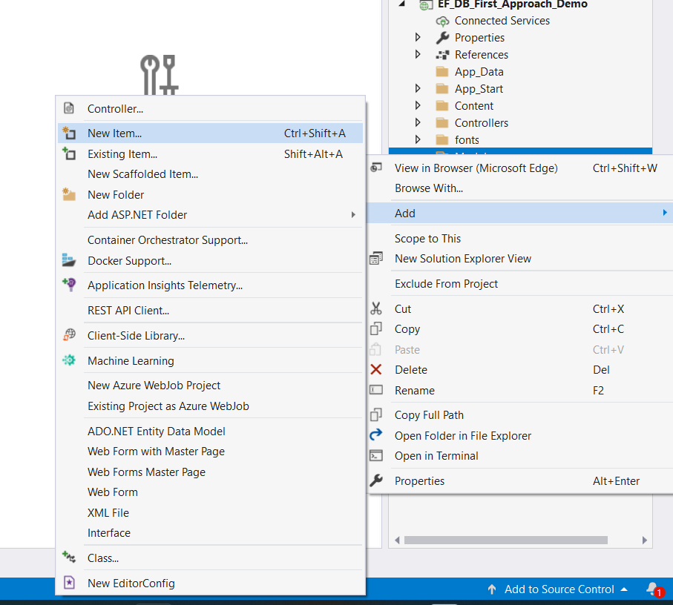

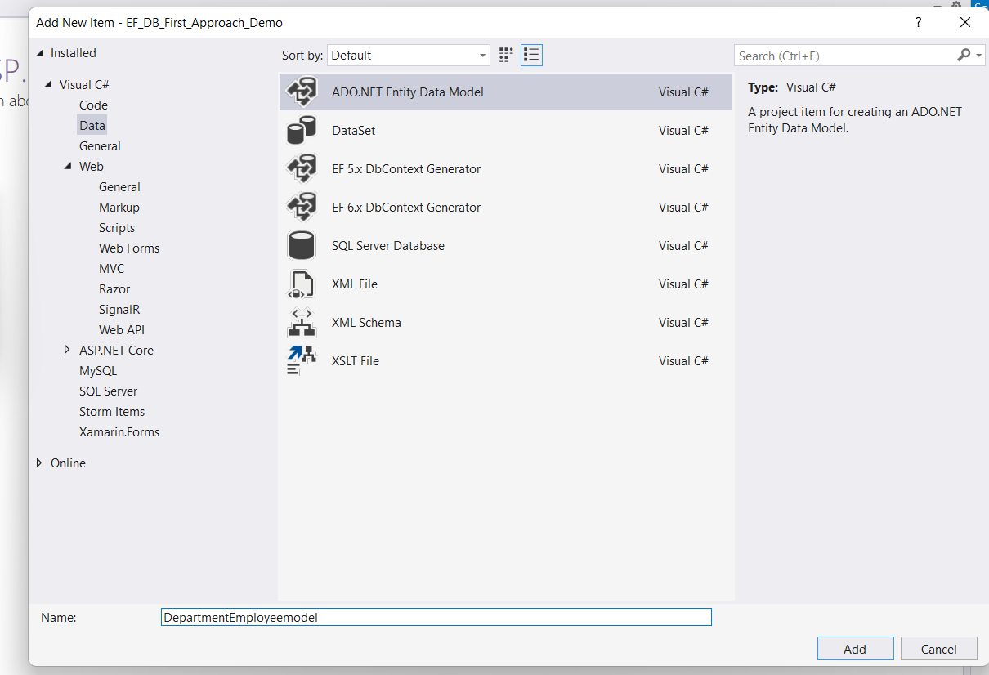

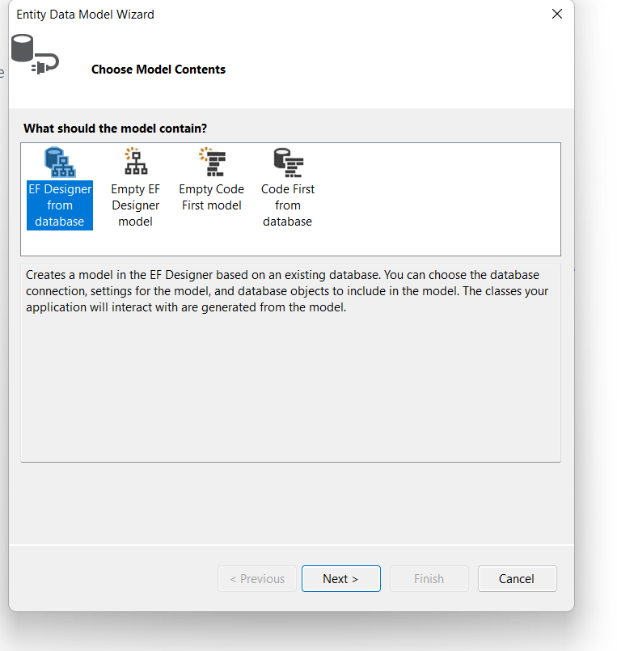

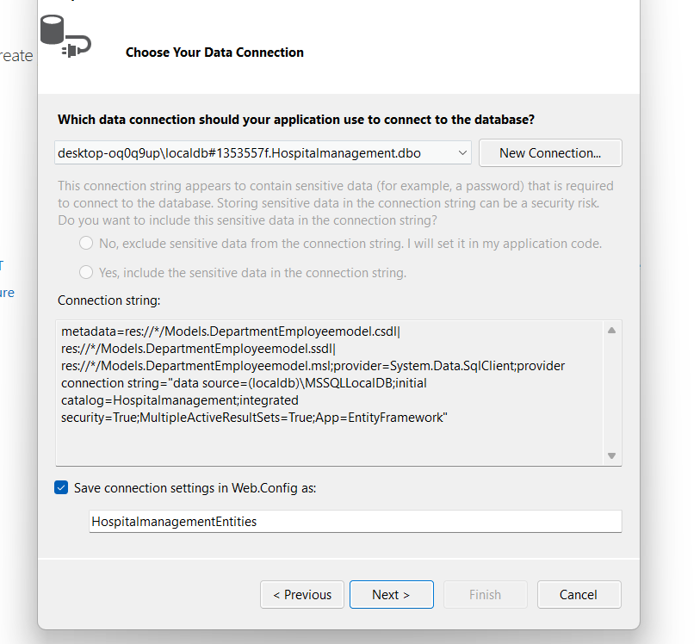

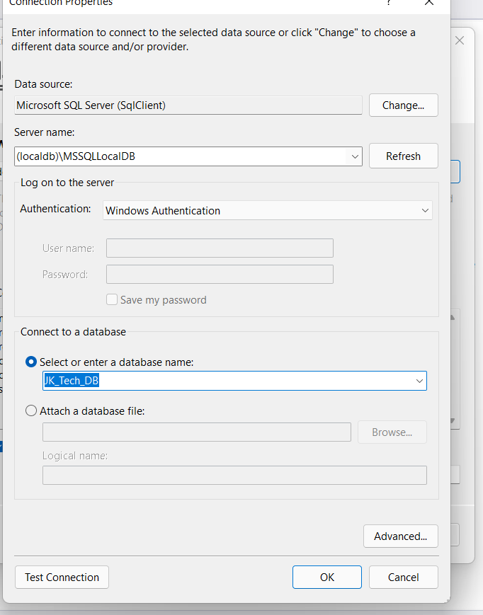

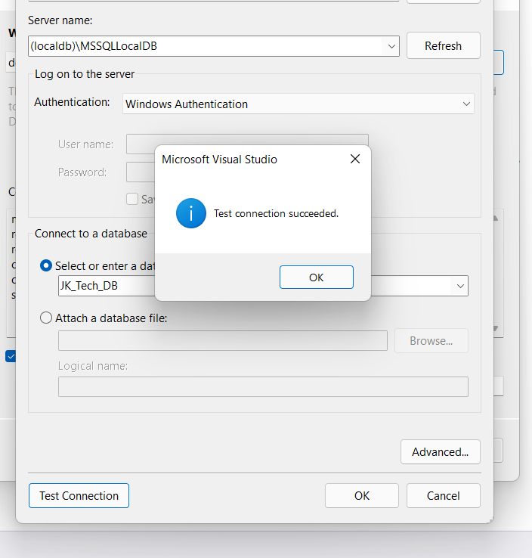

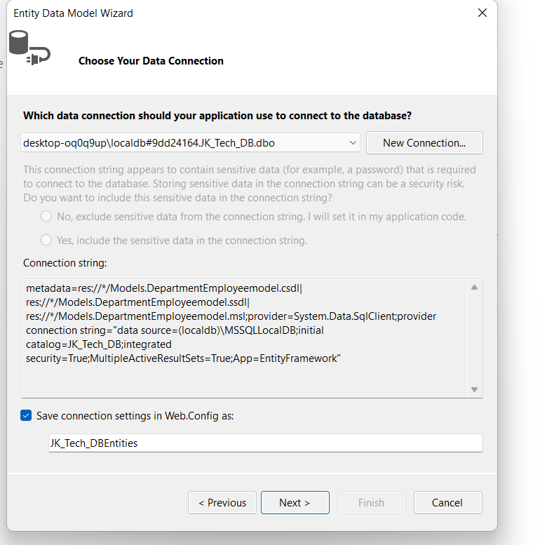

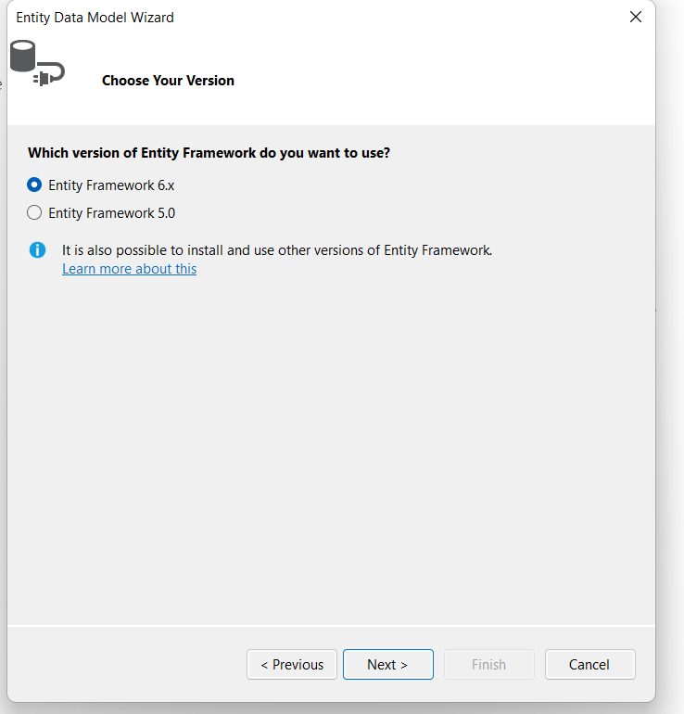

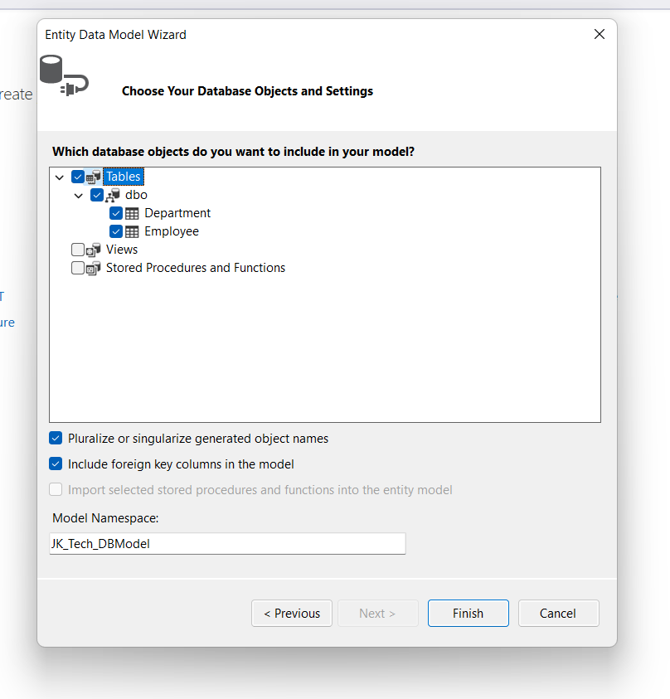

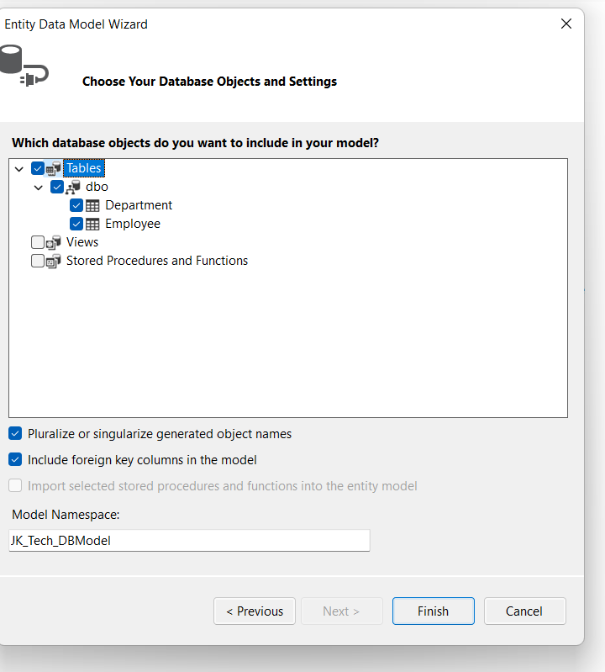

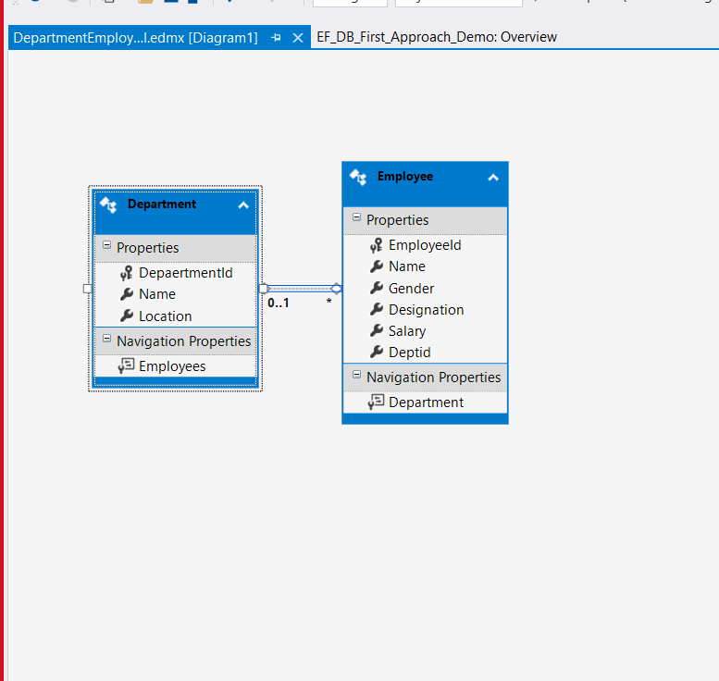

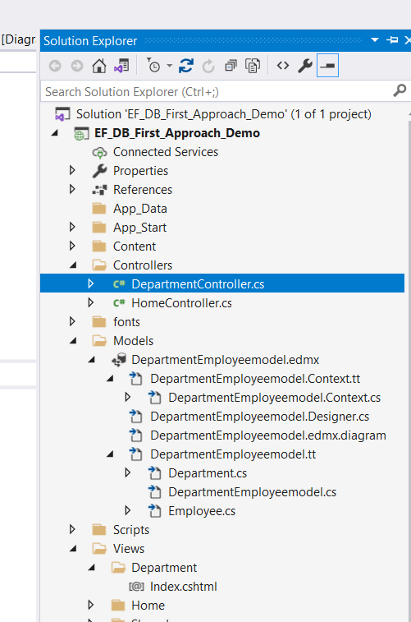

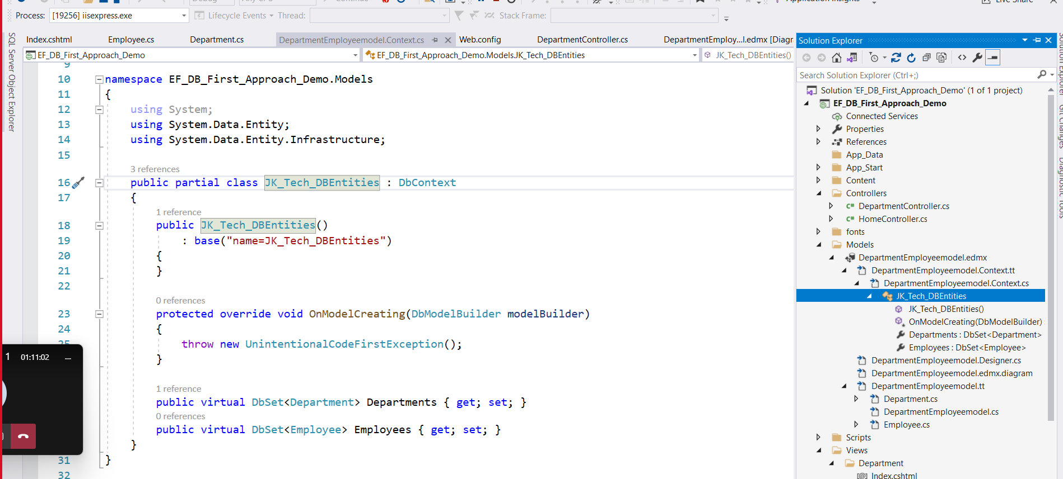

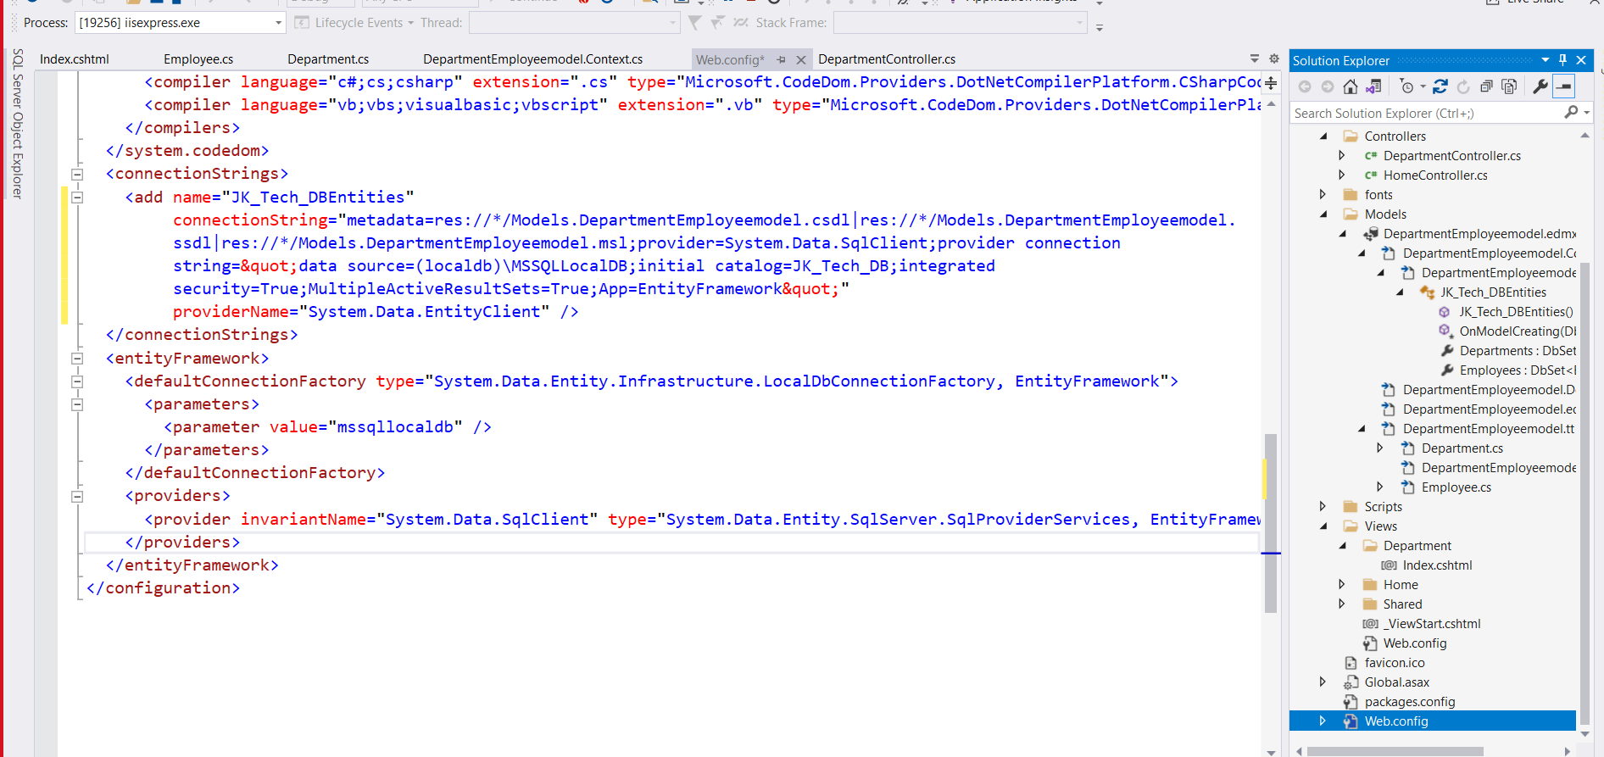

Build solution.

Right click on Controllers folder 🡺 Add new Controller

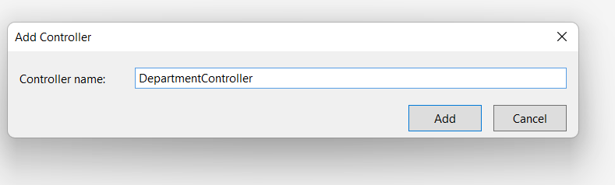

Right click on Index action in Department Controller

